
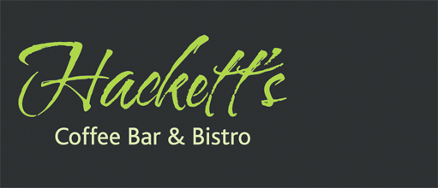
Chess Club Annual Dinner Saturday May 7th 2011

Starters

Duck Liver Pâté
With homemade apple and pear jam & wholemeal toast

Wild Mushroom & Goats Cheese Tart
With caramelised red onion and a watercress salad

Black Pudding & Chorizo Salad
With free range poached egg

Creamy Garlic Mushrooms
Served on toasted onion ciabatta

Mains

8oz Rump Steak
With salad, fries & onion rings and peppercorn sauce

Roast Pork Belly with rich pan jus
Spring onion mash, creamed cabbage & bacon, black pudding

Sea Bream Fillet on Asparagus & Pea Risotto
With roasted cherry vine tomatoes, rocket pesto

Spinach Ricotta Cannelloni
Served with garlic ciabatta & rocket salad

Desserts

Rhubarb Fool
with Lavender Shortbread

Hazelnut Meringues
With hazelnut praline cream & caramel syrup

Hackett’s Chocolate Brownie
With hot chocolate sauce & ice cream

Raspberry & White Chocolate Crème Brulée
With homemade cookie

Coffee & Mints to finish

