Frank Wood Shield semi final
28 March 2011
Witney 2 ½ - 5 ½ Oxford 1
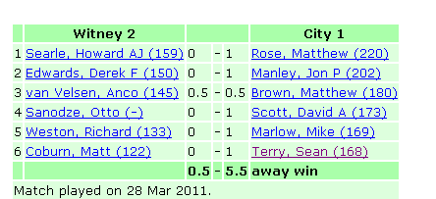

In the end a comfortable win for the visitors, who needed to score 4 points to gain a match victory against the Witney second side – a result which somewhat flattered Oxford while masking some performances of merit by the hosts. You don’t always get the result your play deserves – even if, in the end, mate is mate = mate.

The top two boards were interesting tussles, which went the way the ratings suggested they would. Matt on top board opted for the quieter positional route to Howard’s king in the Modern Defence, and was prepared to sacrifice a queen-side pawn in the cause. A minor piece attack on a fianchetto-ed king is always an intricate matter, and here end was hastened when both of black’s rooks were awkwardly placed, on e6 and a6, and helpless to protect against the invasion of the queen and white knights. On board 2, Jon’s more positive moments in a closed Sicilian resulted in more solid pawn structure, more space in the middle game, and left Derek struggling for space to manoeuvre: his position deteriorated fatally after the mass exchanges initiated on move 30.

The middle two boards showed the most variation, with a series of errors from the opening first gifting Matt a clear plus in a c3 Sicilian, before he returned the gift to leave a position where a draw was agreed on move 23. The real drama was the battle on the c-file in Sanodze – Scott, where in the diagram position, it’s quite clear that the very least White has in an extremely comfortable position – his Rook on c5 can’t be challenged and Black has been reduced to reactive passivity, needing to keep his pieces exactly where they they are in order to prevent a decisive invasion of the knight on a5.
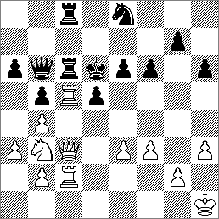
Sanodze – Scott (W, 34)

Play continued 34.e4 dxe4 35.Qd4+ Ke7 36.Qxe4 R6c7 37.Qe3 Qd6 38.Rxc7+ Rxc7 39.Rxc7+ Nxc7 and by now the position had become a lot less dangerous for Black, who went on to win after a mis-timed queen exchange… … but what did he miss in the course of the continuation that made Fritz hop from +1.5 to about +3.5 in its estimation of the position? (Answer at end)
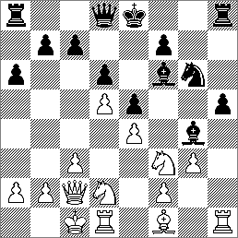
Coburn – Terry (B, 17)
17…. Bg7 18.Bh3 Qf6 19.Rdf1? Bxf3 (&c)
The lower two boards weren’t quite as filled with drama or content as the rest of the match, although Mike Marlow eventually took on the look of someone who was enjoying his advantage against Richard Weston’s expansive double-fianchetto play, sacrificing a piece to remove the Black king’s defensive pawn cover.

My own game featured some expansive play against Matt Coburn, but not necessarily of the right kind. The game ended quickly after a blunder by Matt – but not before (in the diagram position), I had come to the conclusion – since corroborated by Fritz, who provides +0.56 snap judgement – that all this busy play by myself had, in the absence of a clear plan, only served to provoke weaknesses in my own position…

Sean Terry
03 April 2011

