
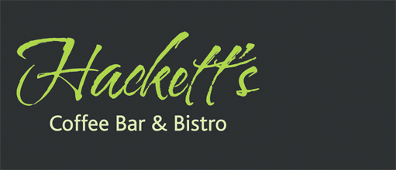
Chess Club Annual Dinner Friday 18th May 2012

Starters

Trio of Homemade Pâtés,
Smoked Mackerel and Chive, trout and crème fraiche,
smoked salmon with oatcakes and salad garnish

Grilled Asparagus, Poached Egg,
hollandaise and crisp pancetta (v optional)

Goan Style Chicken Skewers
mango salsa, coriander and tomato salad

Mains

Smoked Haddock Fishcakes
with wilted spinach, watercress and beurre blanc

Pancetta Wrapped Chicken Breast
French beans, parmentier potatoes and mustard grain sauce

Asparagus and Applewood Smoked Tartlet
with crushed new potatoes (v)

Desserts

Gooseberry Pie
with elderflower custard

Banoffee Profiteroles
banana cream, toffee ice cream and chocolate sauce

Raspberry & White Chocolate Crème Brulée
with popping candy shortbread

Coffee & Mints to finish

