Sponsors

We are very grateful to our sponsors, Hacketts Outside Catering Ltd: www.hackettsgroup.co.uk / 01993 700858.

Sections

If entries permit, we will separate entries into: (a) a Minor section for under 50 ECF grade/ungraded players; (b) a Major section which is open to all players, whether graded or ungraded. If your child is eligible for both sections, please indicate on the entry form which section you would like him/her to play in.

Child supervision

Due to the limited number of personnel, the responsibility of supervising children remains that of their parents or other responsible adults.

If this is your child’s first chess tournament, we recommend that you remain on site until your child is settled and preferably for the whole day, as chess tournaments can be quite tiring for children not used to them.

The tournament is organised by those with experience of dealing with children and running chess tournaments.

Prizes

Lots of trophies, medals and certificates! In addition, there will be good quality trophies for permanent retention for the top three places in each section. Ties will be broken using sum of progressive scores, followed by sum of opponents’ scores if needed.

Chief Arbiter

FA Dave Thomas

Getting there

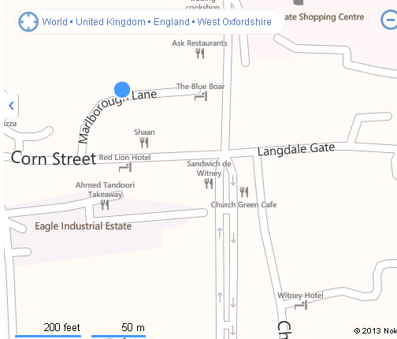

The school is in Marlborough Lane, which is on the right hand side as one proceeds down Corn Street from the east. If coming by bus from Oxford, the S1 and S2 buses (Stagecoach) stop at Buttercross in the Centre of Witney just a few yards from the school.

Car Parking

Car parking is available on site. There is also unrestricted parking in Corn Street, Church Green and the other streets nearby.

Refreshments

Refreshments will be available on site, provided by Hacketts Outside Catering Ltd.

WITNEY CHESS CLUB

www.witneychess.co.uk

JUNIOR RAPIDPLAY
CHESS TOURNAMENT

Sunday
22 September 2019
9.30am till 6.00pm

The Batt School
Corn Street
Witney
Witney OX28 6DY
www.thebattschool.org.uk

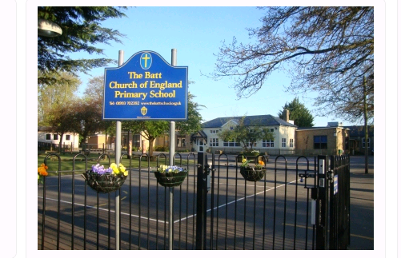

Timetable

9.30 am Doors open and registration
10.00 am Round 1
11.15 am Round 2
12.30 pm Round 3
1.45 pm Round 4
3.00 pm Round 5
4.15 pm Round 6
5.30 pm Prize giving
6.00 pm Close

Time Limits

Each player will be allowed 20 minutes plus 10 seconds increment per move for the game (15 minutes with no increment per player per game in the Minor section, in which two games per round with alternating colours will be played). The organisers reserve the right to change times of rounds and/or time limits if circumstances require it. Clocks will be used (instructions on how to use clocks will be given if required before the start of the tournament).

Qualification for Entry
Players should know how the pieces move, including castling, pawn promotion and the ‘en passant’ rule. They should be under 18 on 1 September 2019.

Late Arrival for Any Round
Players arriving more than ten minutes after the start time of any round may be deemed to have lost by default, unless the arbiter can pair them satisfactorily. Players whose opponents have not arrived must expect to be re-paired.

Entry Fee
The basic entry fee is £10.00, one of the lowest entry fees in England for an event of this kind.

For the Major section only, please add a pay to play congress fee of £2.00 if you are not an ECF member at Silver level or above for the 2019/2020 membership year.

If you enter on the day an additional £5.00 will be added.

Tournament Arrangements
The tournament will be run using a SWISS system. For those not familiar with the system; if your child loses their first round, they are almost certain to play someone else who has lost their first round. Thereafter, they play people on roughly equal points to them. The advantage of this system is that very quickly children end up playing others of the same ability and the likelihood of your child losing all his/her matches is very low.

Results in the Major section only will be submitted for ECF rapidplay grading.

Photographs
Witney Chess Club would like to take photographs of competitors on the day for publication on its website: www.witneychess.org.uk. If you object to this, please inform Mike Truran by email before the tournament.

Emergency Contact Numbers
During the tournament if you need to contact us in an emergency, Dave Thomas’s mobile will be left on: 07793 118628. Please make sure that you put your 22 September contact telephone number on the entry form.

Queries
If you have any questions please give Mike Truran a call on 01993 708645. Email queries can be sent to mike@truranfamily.co.uk.

Disclaimer
The organisers accept no responsibility for any damage, theft or accident to the person or property of anyone attending this event. They are unable to act in loco parentis for children and are not able to take responsibility for any child’s actions, or for the actions of anyone that may affect your child. Parents/guardians/teachers, as appropriate, agree to the terms and conditions as set out in this entry form as a condition of their entry. Parents/guardians/teachers are responsible for their children throughout the entire duration of this event.

EITHER ENTER ONLINE AT WWW.WITNEYCHESS.CO.UK, OR SEND COMPLETED ENTRY FORM BELOW AND ENTRY FEE CHEQUE (PAYABLE TO WITNEY CHESS CLUB) TO:

Mike Truran,
The Old Farmhouse, 7 Church Street, Ducklington, Witney OX29 7UA
Tel: 01993 708645 Email mike@truranfamily.co.uk
Entry Fee |  | £10.00
For Major section only, pay to play congress fee (if not ECF 2019/2020 Silver or above member) | +£2.00 | £
Late fee (on 22 Sep) | +£5.00 | £
 | TOTAL | £

PLEASE PRINT CAREFULLY IN BLOCK CAPITALS
NAME _______________________________
EMAIL ____________________________________
ADDRESS _________________________________
______________________________________________________ POST CODE _________________
TELEPHONE _______________________________
Date of Birth ___/____ /_____
CLUB _____________________________________
MALE ____ FEMALE ____
ECF GRADE (if known) _______________________

ECF GRADING CODE _______________________

ECF MEMBERSHIP NO ______________________

SECTION __________________________________

