Sponsors

We are very grateful to our sponsors, Hacketts Outside Catering Ltd: www.hackettsgroup.co.uk / 01993 700858.

Timetable

9.30 am Doors open and registration
10.00 am Round 1
11.15 am Round 2
12.30 pm Round 3
1.45 pm Round 4
3.00 pm Round 5
4.15 pm Round 6
5.30 pm Prize giving
6.00 pm Close

Prizes

There will be good quality trophies for permanent retention for the top three places. Ties will be broken using sum of progressive scores, followed by sum of opponents’ scores if needed.

Chief Arbiter

FA Dave Thomas

Getting there

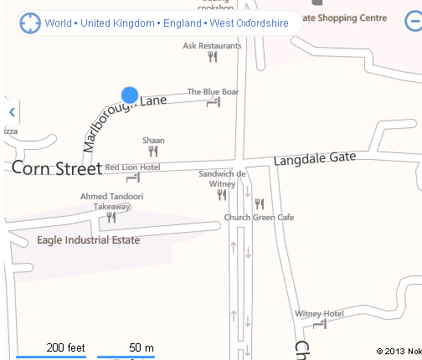

The school is in Marlborough Lane, which is on the right hand side as one proceeds down Corn Street from the east. If coming by bus from Oxford, the S1 and S2 buses (Stagecoach) stop at Buttercross in the Centre of Witney just a few yards from the school.

Car Parking

Car parking is available on site. There is also unrestricted parking in Corn Street, Church Green and the other streets nearby.

Refreshments

Refreshments will be available on site, provided by Hacketts Outside Catering Ltd.

WITNEY CHESS CLUB

www.witneychess.co.uk

OPEN RAPIDPLAY
CHESS TOURNAMENT

Sunday
22 September 2019
9.30am till 6.00pm

The Batt School
Corn Street
Witney
Witney OX28 6DY
www.thebattschool.org.uk

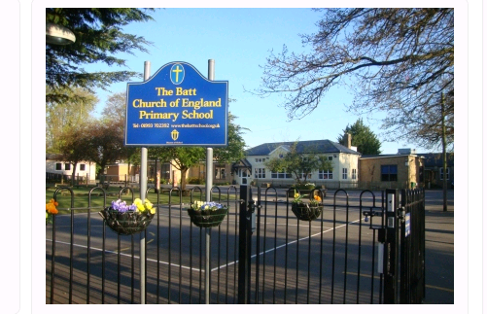

Time Limits

Each player will be allowed 20 minutes plus 10 seconds increment per move for the game. The organisers reserve the right to change times of rounds and/or time limits if circumstances require it.

Late Arrival for Any Round
Players arriving more than ten minutes after the start time of any round may be deemed to have lost by default, unless the arbiter can pair them satisfactorily. Players whose opponents have not arrived must expect to be re-paired.

Entry Fee
The basic entry fee is £10.00, one of the lowest entry fees in England for an event of this kind.

Please add a pay to play congress fee of £7.50 if you are not an ECF member at Silver level or above for the 2019/2020 membership year.

If you enter on the day an additional £5.00 will be added.

Tournament Arrangements
The tournament will be run using a SWISS system.

Results will be submitted for ECF rapidplay grading and (for the first time this year at no extra cost) FIDE rapidplay rating.

Photographs
Witney Chess Club would like to take photographs of competitors on the day for publication on its website: www.witneychess.org.uk. If you object to this, please inform Mike Truran by email before the tournament.

Emergency Contact Numbers

During the tournament if you need to contact us in an emergency, Dave Thomas’s mobile will be left on: 07793 118628. Please make sure that you put your 24 September contact telephone number on the entry form.

Queries
If you have any questions please give Mike Truran a call on 01993 708645. Email queries can be sent to mike@truranfamily.co.uk.

Disclaimer
The organisers accept no responsibility for any damage, theft or accident to the person or property of anyone attending this event.

EITHER ENTER ONLINE AT WWW.WITNEYCHESS.CO.UK, OR SEND COMPLETED ENTRY FORM BELOW AND ENTRY FEE CHEQUE (PAYABLE TO WITNEY CHESS CLUB) TO:

Mike Truran,
The Old Farmhouse, 7 Church Street, Ducklington, Witney OX29 7UA
Tel: 01993 708645 Email mike@truranfamily.co.uk
Entry Fee |  | £10.00
Pay to play congress fee (if not ECF 2019/2020 Silver or above member) | +£7.50 | £
Late fee (on 22 Sep) | +£5.00 | £
 | TOTAL | £

PLEASE PRINT CAREFULLY IN BLOCK CAPITALS
NAME ____________________________________
EMAIL ____________________________________
ADDRESS _________________________________
______________________________________________________ POST CODE _________________
TELEPHONE _______________________________
Date of Birth ___/____ /_____
CLUB _____________________________________

MALE ____ FEMALE ____
ECF GRADE (if known) _______________________

ECF GRADING CODE _______________________

ECF MEMBERSHIP NO ______________________

FIDE ID CODE (if you have one) _______________

COUNTRY (if not England) _________________

