Sponsors

We are very grateful to our sponsors, Hacketts Outside Catering Ltd: www.hackettsgroup.co.uk / 01993 700858.

You will receive a 10% discount on all food purchases at Hacketts restaurants in Witney, Carterton and Burford on production of this entry form.

Timetable

9.30 am Doors open and registration
10.00 am Round 1
11.15 am Round 2
12.30 pm Round 3
1.45 pm Round 4
3.00 pm Round 5
4.15 pm Round 6
5.30 pm Prize giving
6.00 pm Close

Prizes

There will be good quality trophies for permanent retention for the top three places. Ties will be broken using sum of progressive scores, followed by sum of opponents’ scores if needed.

Chief Arbiter

FA Matthew Carr

Getting there

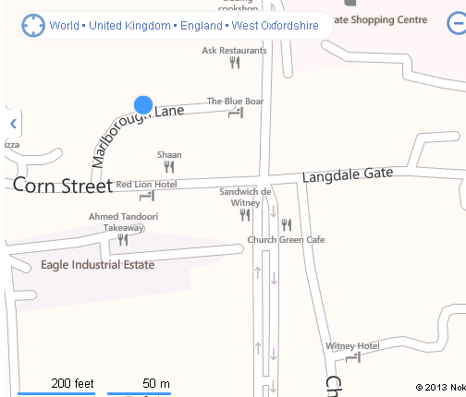

The school is in Marlborough Lane, which is on the right hand side as one proceeds down Corn Street from the east. If coming by bus from Oxford, the S1 and S2 buses (Stagecoach) stop at Buttercross in the Centre of Witney just a few yards from the school.

Car Parking

Car parking is available on site. There is also unrestricted parking in Corn Street, Church Green and the other streets nearby.

Refreshments

Refreshments will be available on site, provided by Hacketts Outside Catering Ltd.

WITNEY CHESS CLUB

www.witneychess.co.uk

RAPIDPLAY
CHESS TOURNAMENT

Sunday
25 September 2016
9.30am till 6.00pm

The Batt School
Corn Street
Witney
Witney OX28 6DY
www.thebattschool.org.uk

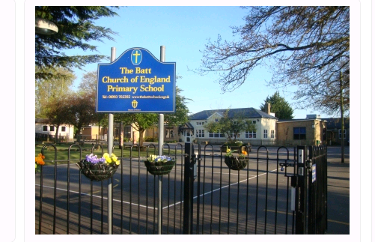

Time Limits

Each player will be allowed 20 minutes plus 10 seconds increment per move for the game. The organisers reserve the right to change times of rounds if circumstances permit.

Late Arrival for Any Round
Players arriving after the re-pairing time of any round may be deemed to have lost by default, unless the controller can pair them satisfactorily. Players whose opponents have not arrived must expect to be re-paired.

Entry Fee
The basic entry fee is £15.00. However, if you are an ECF member at Silver level or higher for the 2016/2017membership year there is a discount of £7.00 which reduces the entry fee to £8.00 – one of the lowest entry fees in England for an event of this nature. ECF Silver membership also gives a range of other benefits
as described here:
http://www.englishchess.org.uk/?page_id=18737. If you intend to claim this discount, please give your ECF membership number on the entry form. An extra fee of £3.00 is payable for any entry postmarked after 18th September 2016, and if you enter on the day an additional £6.00 will be added.

Tournament Arrangements
The tournament will be run using a SWISS system.

Results will be submitted for ECF rapidplay grading.

Photographs
Witney Chess Club would like to take photographs of competitors on the day for publication on its website: www.witneychess.org.uk. If you object to this, please inform Mike Truran by email before the tournament.

Emergency Contact Numbers
During the tournament if you need to contact us in an emergency, Matthew Carr’s mobile will be left on: 07578 163901. Please make sure that you put your 25th September contact telephone number on the entry form.

Queries
If you have any questions please give Mike Truran a call on 01993 708645. Email queries can be sent to mike@truranfamily.co.uk.

Disclaimer
The organisers accept no responsibility for any damage, theft or accident to the person or property of anyone attending this event.

EITHER ENTER ONLINE AT WWW.WITNEYCHESS.CO.UK, OR SEND COMPLETED ENTRY FORM BELOW AND ENTRY FEE CHEQUE (PAYABLE TO WITNEY CHESS CLUB) TO:

Mike Truran,
The Old Farmhouse, 7 Church Street, Ducklington, Witney OX29 7UA
Tel: 01993 708645 Email mike@truranfamily.co.uk
Entry Fee |  | £15.000
ECF membership discount (ECF 2016/2017 Silver membership or higher) | -7.00 | £
Late fee (after 18th Sep) | +£3.00 | £
Late fee (on 25th Sep) | +£6.00 | £
 | TOTAL | £

PLEASE PRINT CAREFULLY IN BLOCK CAPITALS
NAME ____________________________________
EMAIL ____________________________________
ADDRESS _________________________________
______________________________________________________ POST CODE _________________
TELEPHONE _______________________________
Date of Birth ___/____ /_____
CLUB _____________________________________

MALE ____ FEMALE ____
ECF GRADE (if known) _______________________

ECF GRADING CODE _______________________

ECF MEMBERSHIP NO ______________________

